**Stage 3 – I’m glad we didn’t go to Nationals**

**COURSE DESIGNER:** Stolen from 2025 Factory Gun Nationals Stage 21

|  |
| --- |
| **SCORING:** Comstock 31 rounds.  **TARGETS:** 14 cardboard targets, 3 steel targets  **SCORED HITS:** 2 Best hits per carboard will be scored, steel must fall to score. |

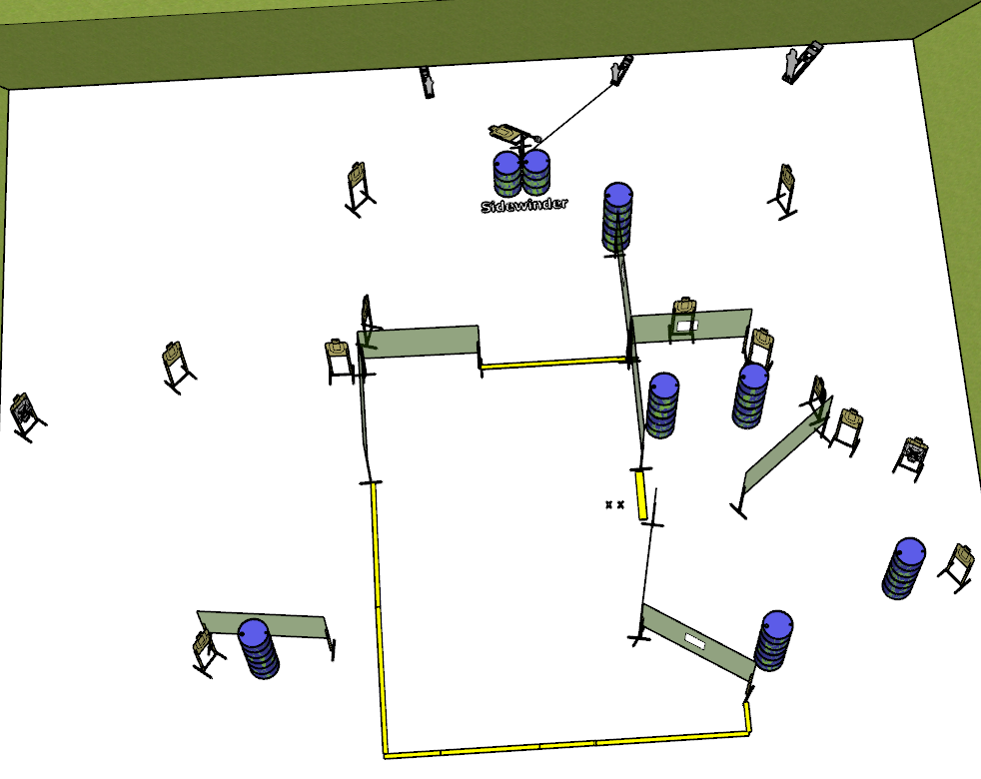

**Written Stage Briefing:**

**Stage 3 – I’m glad we didn’t go to Nationals-** is a 31-round, 155 point, Comstock Long Course. There are 14 cardboard targets and 3 steel targets. The best 2 hits per cardboard target will be scored. The steel must fall to score.

**Start position** Feet on Xs.

**Handgun: Loaded** and holstered.

**PCC: Loaded**, stock on belt

On the audible start signal, engage targets from within the shooting area.

**Setup Notes:**

11 Single Wall Stands

2 Double Wall Stands

1 Triple Wall Stand

6 Full Walls

3 Port Walls

1 Sidewinder

1 Large Popper

1 Mini Popper

1 Mini Popper Activator + cables

13 Target stands / 26 target sticks

14+ barrels

1 Starting Xs